**What is JavaScript**

**Intro to JavaScript**

JavaScript is a programming language created for the web.

But today, JavaScript is used for all sorts of applications.

In this course, we will learn about the foundations of JavaScript, and familiarize ourselves with the tools used by JavaScript programmers.

Finally, get practice with the basics of the language.

**History of JavaScript**

JavaScript is a programming language created in 1995. JavaScript is used to communicate instructions to a machine. It can control the behaviour of a machine and express algorithms.

Today, the language itself is still referred to as JavaScript, but recent versions are referenced by their ECMAScript version number.

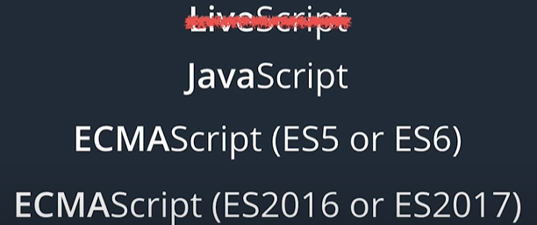

**The JavaScript Console**

You can find the JavaScript Console in Google Chrome:

* Open Google Chrome
* Right click and select Inspect (Ctrl+Shift+J)
* Click in the Console tab.

<https://developer.chrome.com/docs/devtools/shortcuts/>

**Developer Tools on Different Browsers**

Every modern web browser includes its own set of developer tools.

We’ll be using Google Chrome.

**console.log**

console.log is used to display content to the JavaScript console. Run the following code in the console:

console.log("Hi Fernando. What’s up?");

It works as the print command when using python.

Now, let’s try using the console.log command inside a loop:

**for** (**var** i = 0; i < 10; i++) {

console.log(i);

}

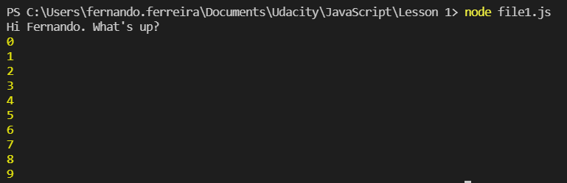

**JavaScript Demo**

Open [the following site](https://daringfireball.net/projects/markdown/) in a new tab and in that tab also open up developer tools. Then paste the following code:

document.getElementsByTagName("h1")[0].style.color = "#ff0000";

We can see that the heading changed the color to red.

Now, let’s refresh the page and paste the following lines of code:

document.body.addEventListener('click', **function** () {

**var** myParent = document.getElementsByTagName("h1")[0];

**var** myImage = document.createElement("img");

myImage.src = 'https://thecatapi.com/api/images/get?format=src&type=gif';

myParent.appendChild(myImage);

myImage.style.marginLeft = "160px";  
});

Now, when clicking on the page, an image is shown.